Jenkins Pipeline Challenge
- Create one Declarative pipeline job
  - Source Code: https://github.com/betawins/spring3-mvc-maven-xml-hello-world-1.git

Step 1: Check java version, maven version and git version on Jenkins server
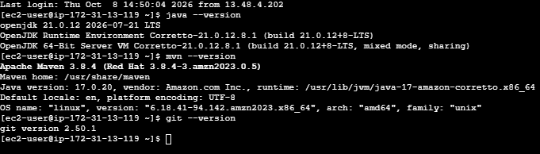

Step 2. First check Jenkins server
Since you are using your Jenkins EC2 server, open Jenkins in your browser:
http://YOUR-JENKINS-PUBLIC-IP:8080
Make sure Jenkins is running.
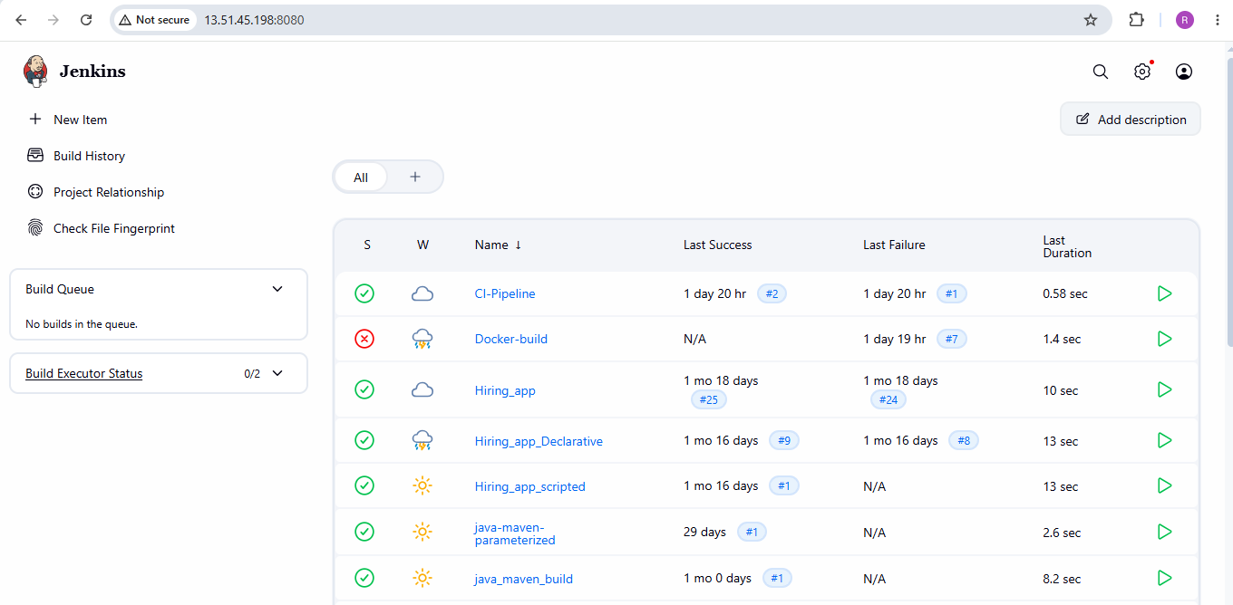
Step 2 — Check the project before creating Jenkins job
On the Jenkins EC2 machine, run:
On the Jenkins EC2 machine, run:
cd /tmp
Clone the assignment repository:
git clone https://github.com/betawins/spring3-mvc-maven-xml-hello-world-1.git
Enter the project:
cd spring3-mvc-maven-xml-hello-world-1
Check the files:
ls
You should see something similar to:
pom.xml
src
...
Most importantly, check the Maven POM:
grep -n "source\|target\|jdk.version" pom.xml

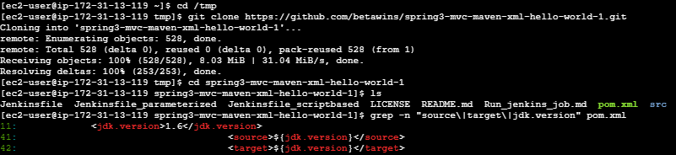
Then test Maven before involving Jenkins: mvn clean package

This step is very important
If this command succeeds: BUILD SUCCESS
then the project itself can be built with your current Maven/Java environment.
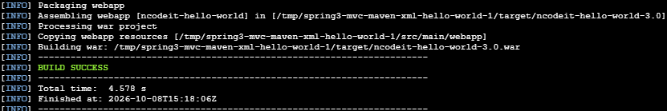

Step 3. Create the Declarative Pipeline job
From the Jenkins Dashboard: New Item
Enter: spring3-mvc-maven-pipeline
Select: Pipeline
Then click: OK
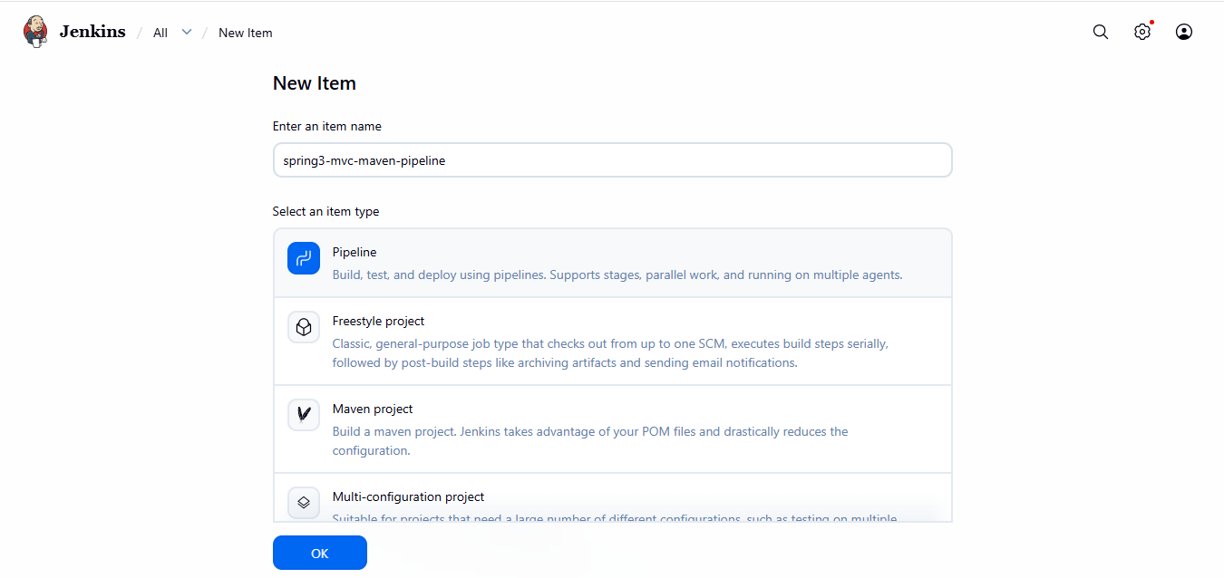

Step 3. Configure the Pipeline
Scroll down to the Pipeline section.
For: Definition
Select: Pipeline script from SCM
Then: SCM
Select: Git

Repository URL
Enter: https://github.com/betawins/spring3-mvc-maven-xml-hello-world-1.git

Credentials: Select: - none -
The repository is public, so we don't need GitHub credentials.

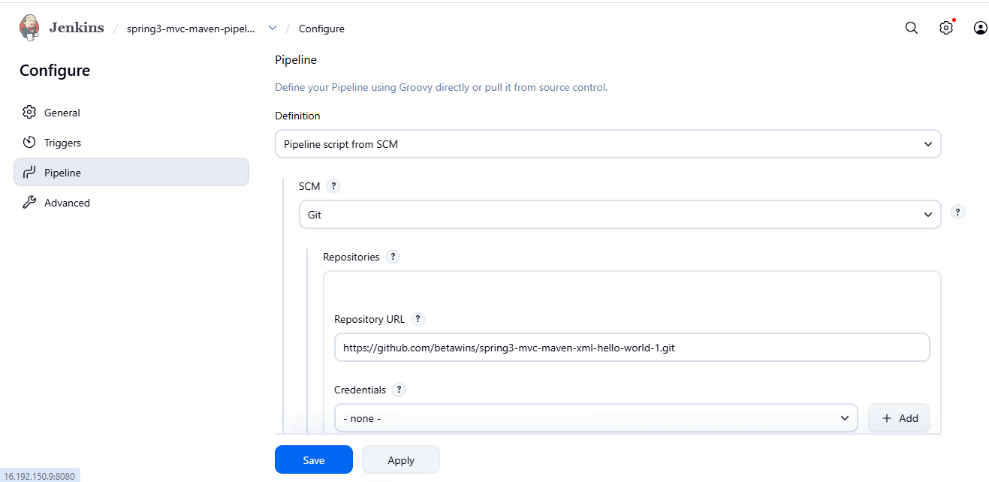

Step 4 — Select the branch
Check the repository first using command:
git ls-remote --heads https://github.com/betawins/spring3-mvc-maven-xml-hello-world-1.git
As it showed refs/heads/master, we can use master
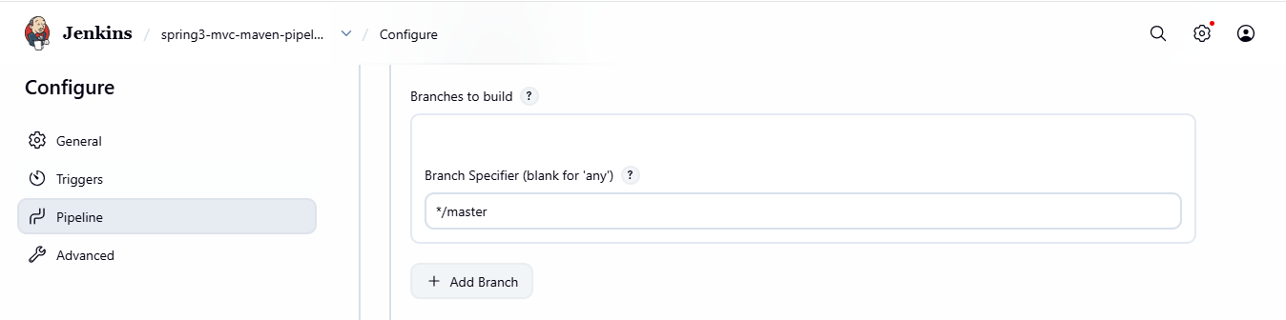

Step 5 — Script Path
The Jenkins documentation specifies that the Script Path should match the location of the Jenkinsfile inside the repository; the default is Jenkinsfile at the repository root.
Our repository may not already contain a Jenkinsfile. So we have to check it with command:
cd /tmp/spring3-mvc-maven-xml-hello-world-1 find . -maxdepth 2 -name Jenkinsfile -print
As the above output showed ./Jenkinsfile, We say that our repository contain a repository.

Step 8 —Run mvn clean package –DskipTests
This makes the first pipeline focus on:
Git checkout → Maven compilation → package
rather than potentially failing because of an old/incompatible test configuration.
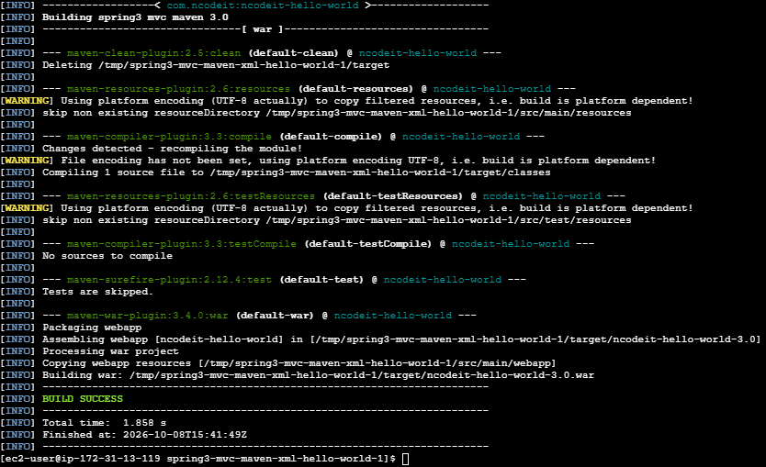

Step 9. Save the job
Click: Save
You should now see your Jenkins job: spring3-mvc-maven-pipeline
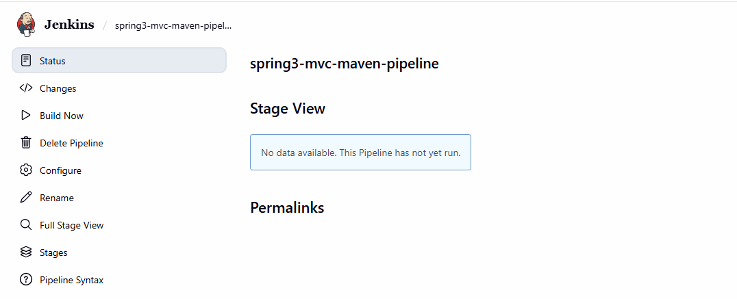

Step 10. Run the pipeline
Open the job and click: Build Now
Jenkins should create: #1
Click: #1 → Console Output
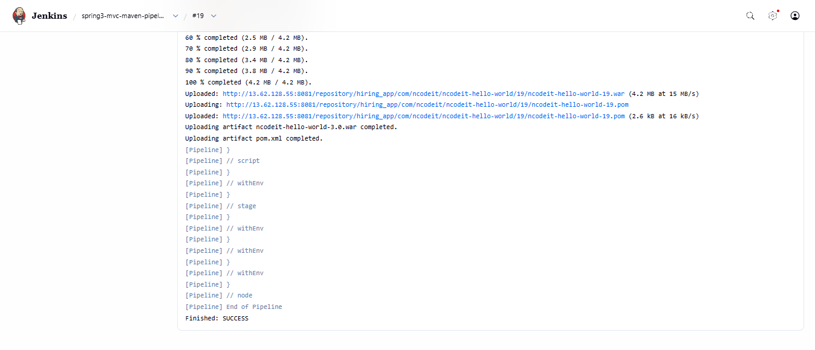
Stage view:
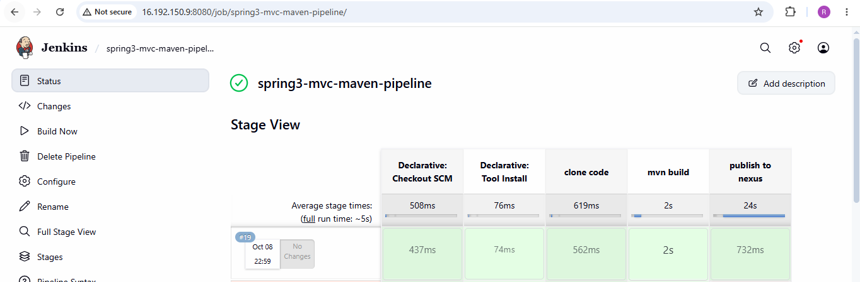

Step 11 — Verify the generated artifact
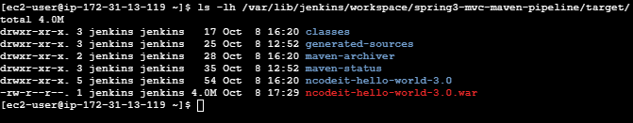
2. Create one Scripted pipeline job
  - Source Code: https://github.com/betawins/spring3-mvc-maven-xml-hello-world-1.git

1. Create the Jenkins job
Go to: Jenkins Dashboard → New Item
Enter: spring3-mvc-scripted-pipeline
Select: Pipeline
Click: OK
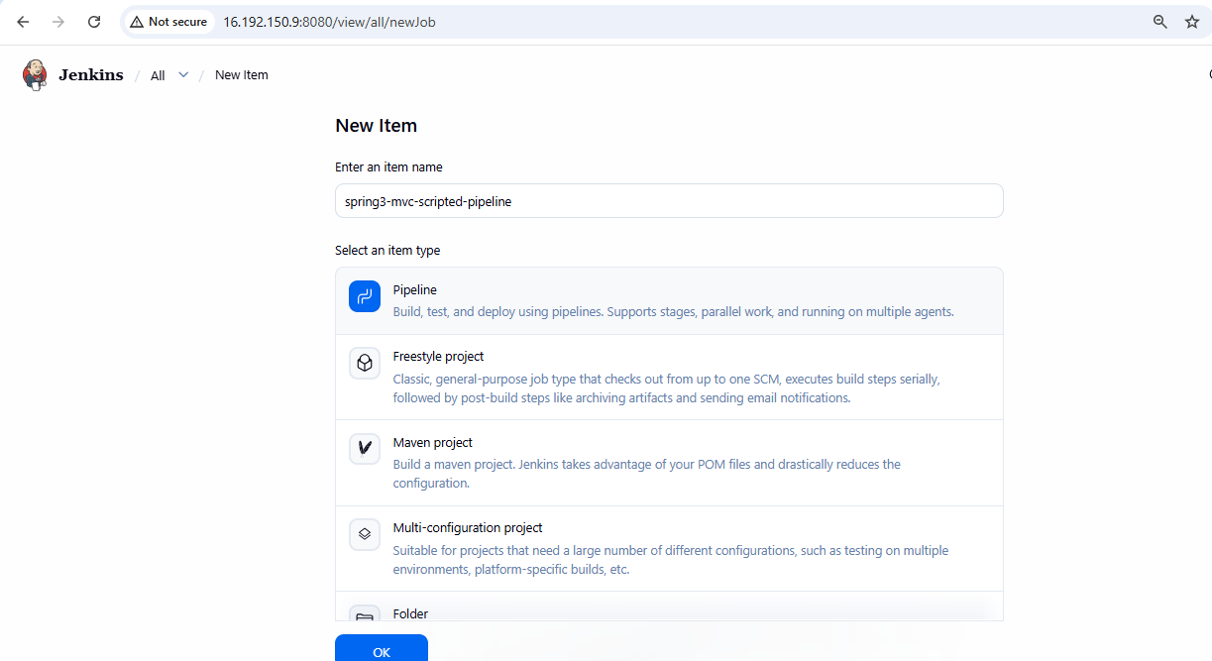

2. Configure Pipeline
Scroll down to Pipeline.
For Definition, select: Pipeline script and write the script
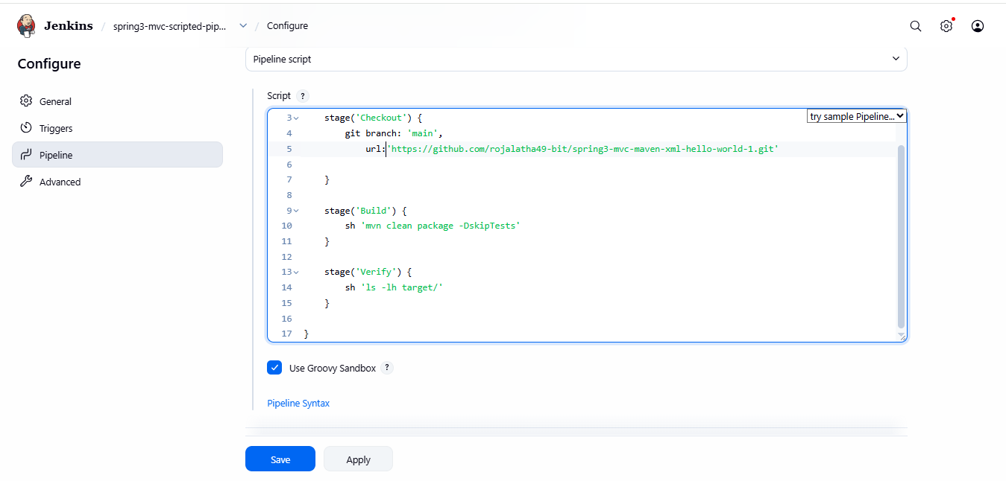
Click on save.

5. Run it
Open: spring3-mvc-scripted-pipeline
Click: Build Now
Then click: #1 → Console Output
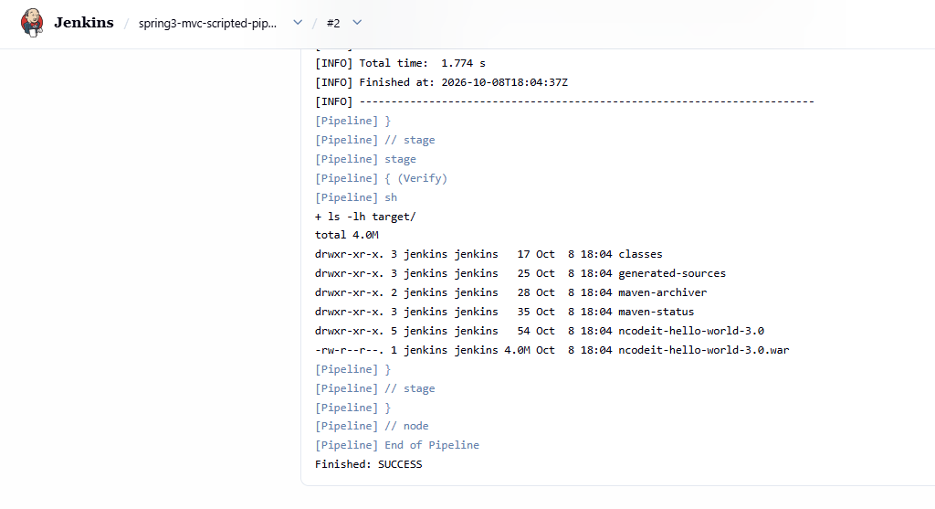
Stage view:
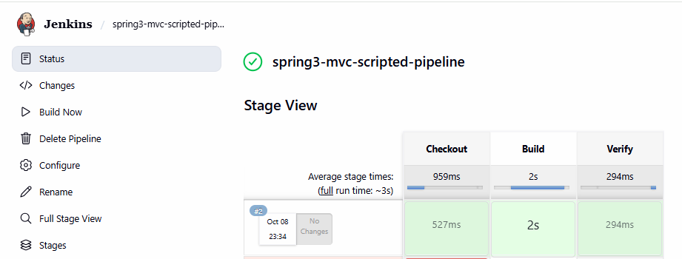

3. Create one Parameterized job
- Source Code: https://github.com/betawins/spring3-mvc-maven-xml-hello-world-1.git

Step 1 — Create a new Jenkins job
On your Jenkins dashboard:
- Click New Item.
- Enter the job name: spring3-mvc-parameterized-pipeline
- Select Pipeline.
- Click OK.
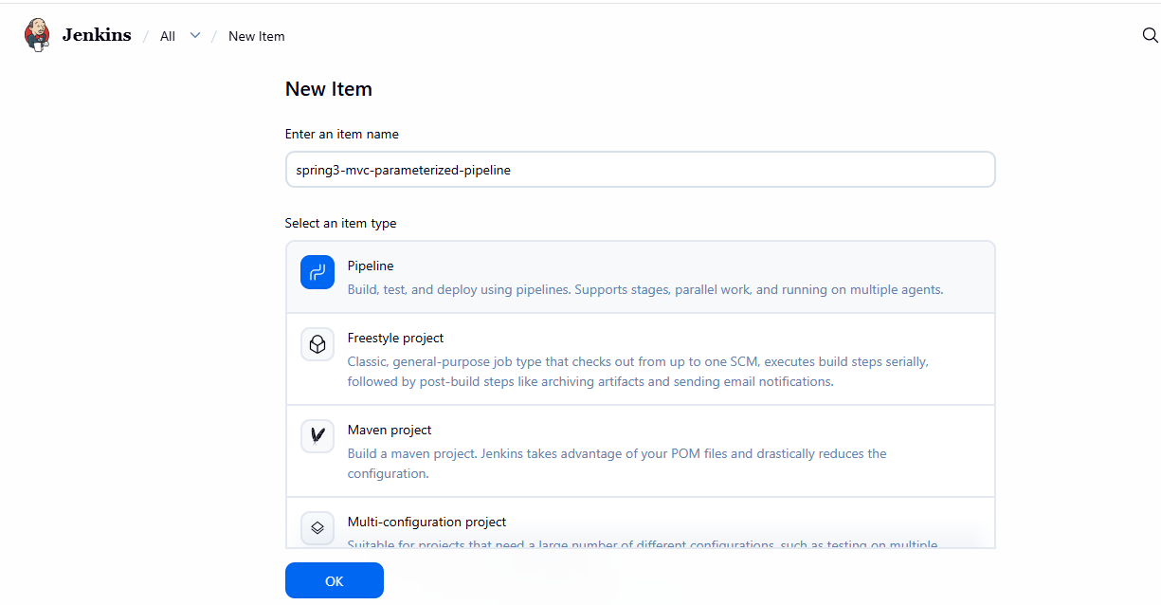

Step 2: Add a build parameter
- Open Configure.
- Find This project is parameterized and check it.
- Click Add Parameter → Choice Parameter.
- Enter these values:
Name: BUILD_ACTION
Choices: Test, package, install
Description: Select the Maven action to execute.
This lets you choose test, package, or install each time you build.
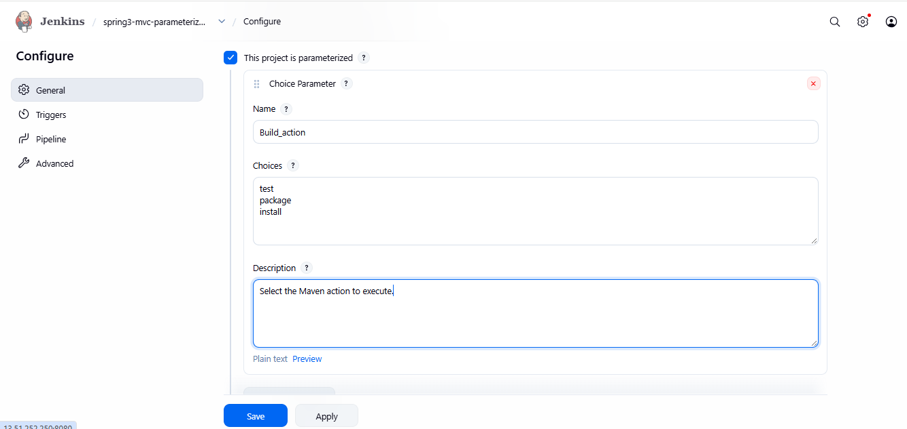

Step 3: Configure the Pipeline
Under Pipeline, choose Pipeline script in the Definition dropdown.
Write the script
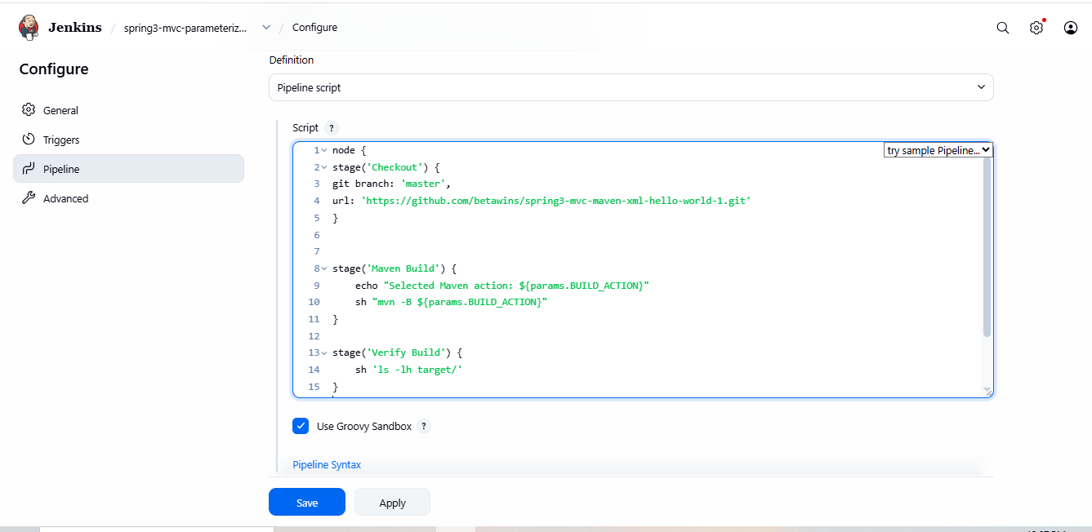

Step 4: Save and run
- Click Save.
- Click Build with Parameters.
- Select a BUILD_ACTION value, test.
- Click Build.
- Open Console Output and check for BUILD SUCCESS and Finished: SUCCESS.
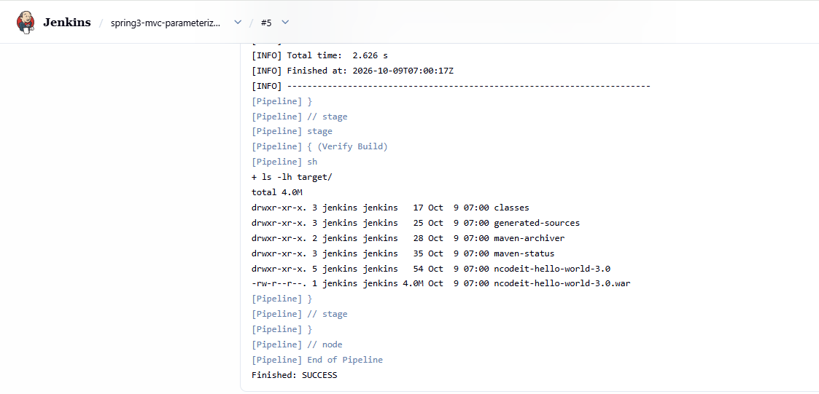

Stage view:
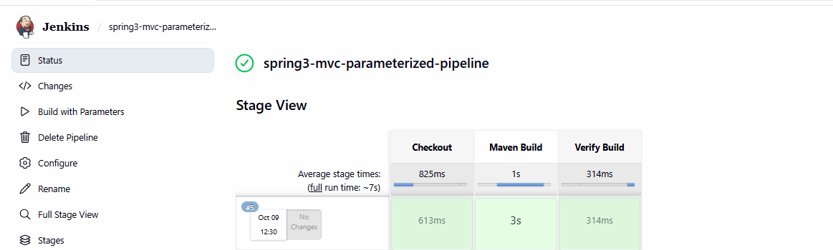
For Build action value-package:
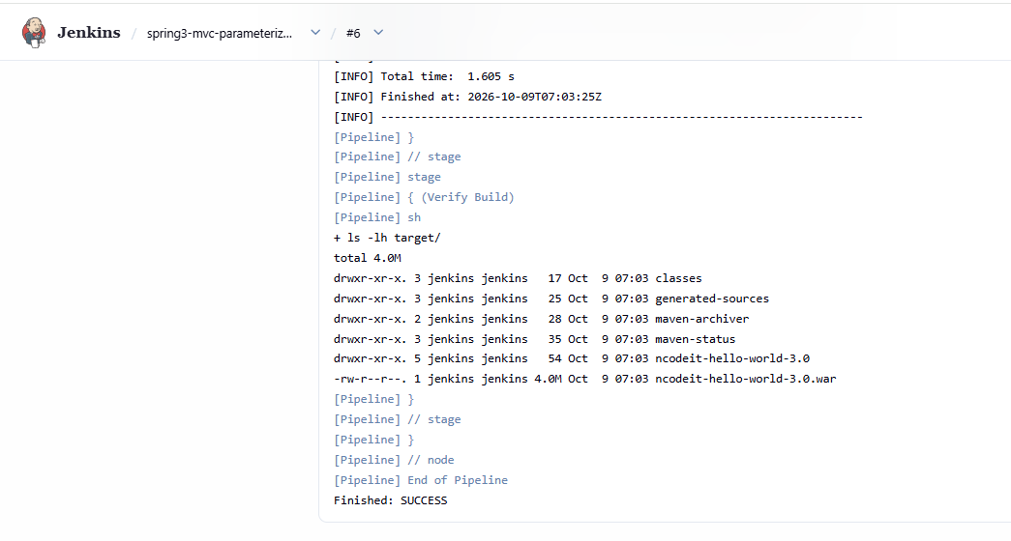
Stage view:
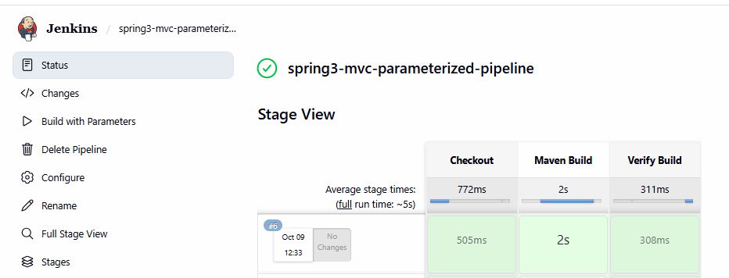

For build action value-install:
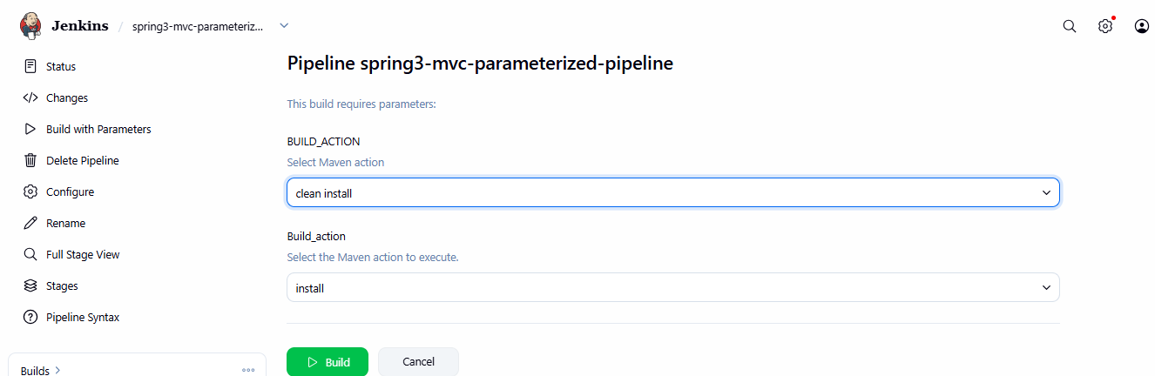
Console output:
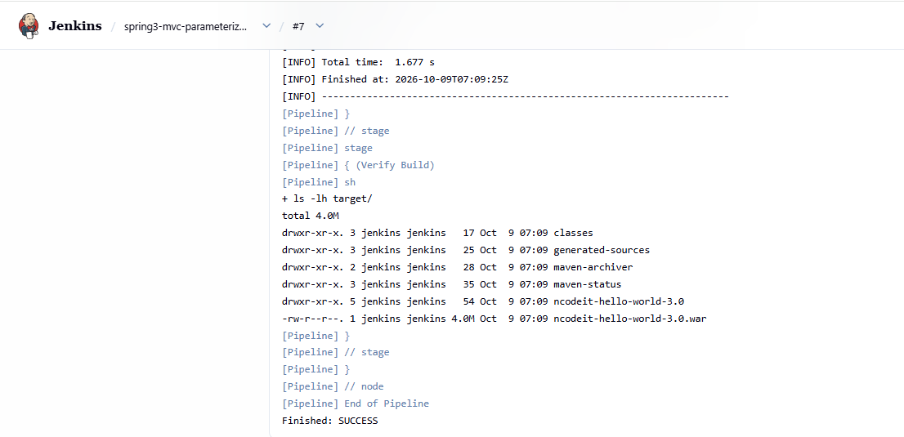
Stage view:
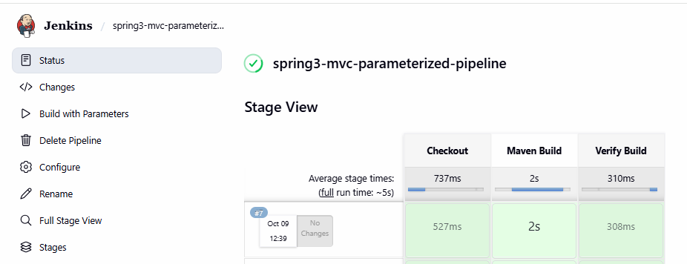
4. Write sample skeleton for Declarative and Scripted pipelines

1. Declarative Pipeline — Sample Skeleton
Declarative pipelines use a structured format with pipeline, agent, and stages.
pipeline {
agent any

stages {
stage('Checkout') {
steps {
echo 'Checking out source code'
}
}

stage('Build') {
steps {
echo 'Building the application'
}
}

stage('Test') {
steps {
echo 'Testing the application'
}
}

stage('Deploy') {
steps {
echo 'Deploying the application'
}
}
}

post {
success {
echo 'Pipeline completed successfully!'
}
failure {
echo 'Pipeline failed!'
}
}
}
Explanation:
- pipeline: Starts the Declarative Pipeline.
- agent any: Runs on any available Jenkins agent.
- stages: Contains the stages of the pipeline.
- stage: Defines an individual stage.
- steps: Contains the commands to execute.
- post: Executes actions after the pipeline finishes.

2. Scripted Pipeline — Sample Skeleton
Scripted pipelines use Groovy code and provide more flexibility through node, stage, and scripting logic.
node {
stage('Checkout') {
echo 'Checking out source code'
}

stage('Build') {
echo 'Building the application'
}

stage('Test') {
echo 'Testing the application'
}

stage('Deploy') {
echo 'Deploying the application'
}

stage('Complete') {
echo 'Pipeline completed successfully!'
}
}
Explanation:
- node: Allocates a Jenkins agent or executor.
- stage: Defines a logical stage of the pipeline.
- echo: Prints a message in the Jenkins Console Output.
- Scripted pipelines allow Groovy logic such as if, for, and try/catch.
Difference between Declarative and Scripted Pipelines
Feature | Declarative | Scripted
Structure | Predefined structure | Flexible Groovy script
Main syntax | pipeline {} | node {}
Learning | Easier for beginners | Requires more Groovy knowledge
Stages | Uses stages {} | Stages are defined inside node
Conditions and logic | Supported using directives and script blocks | Uses Groovy directly

5. Create one Declarative job
- Source Code: https://github.com/betawins/sabear_simplecutomerapp/tree/feature-1.1

Step 1: Open Jenkins and create a job
- Open your Jenkins dashboard.
- Click New Item.
- Enter the job name: sabear-customerapp-declarative.
- Select Pipeline.
- Click OK.
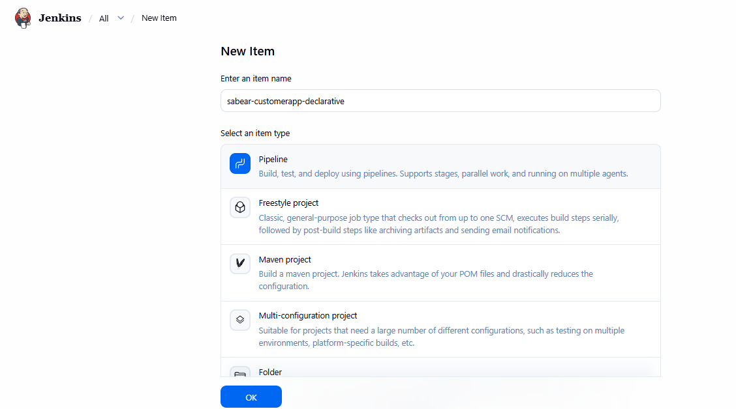

Step 2: Configure the pipeline
Scroll down to the Pipeline section.
Definition: Select Pipeline script
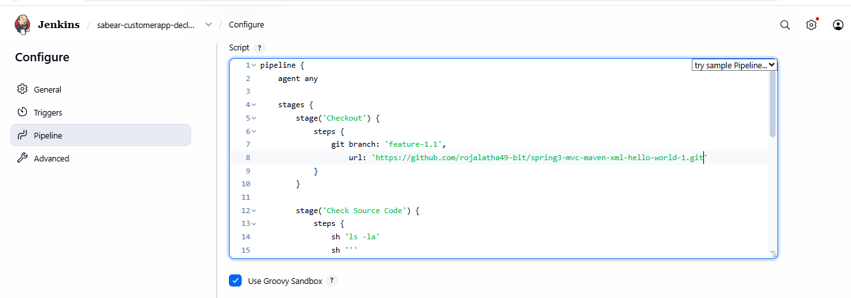

Step 3: Save and run
- Click Save.
- Click Build Now.
- Click the build number, such as #1.
- Click Console Output.
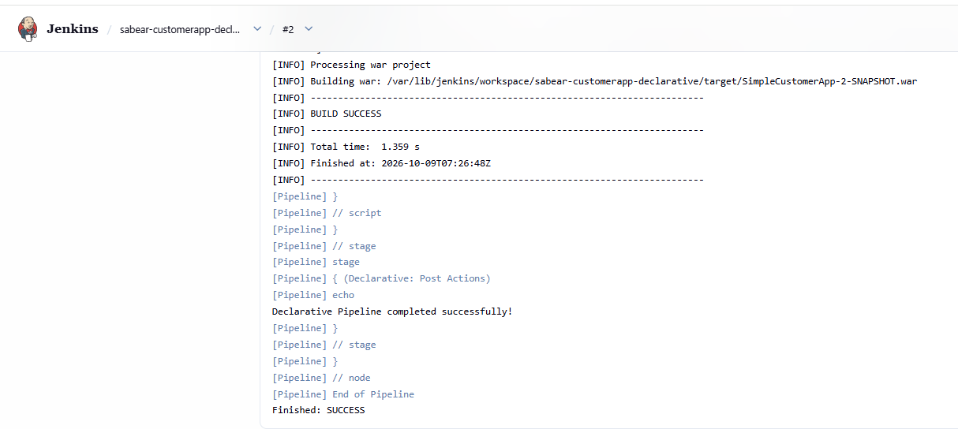

Stage view:
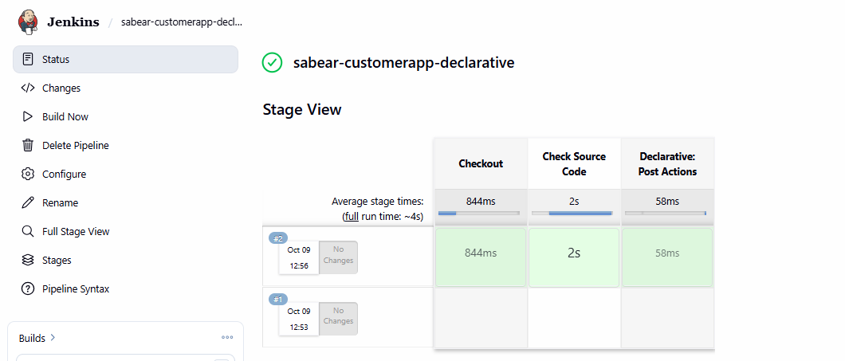
6. Create one Declarative job
- Source Code: https://github.com/betawins/Trading-UI.git

Step 1: Create the Jenkins job
- Open your Jenkins dashboard.
- Click New Item.
- Enter Trading-UI-Declarative.
- Select Pipeline and click OK.
- Scroll down to the Pipeline section.
- Set Definition to Pipeline script.
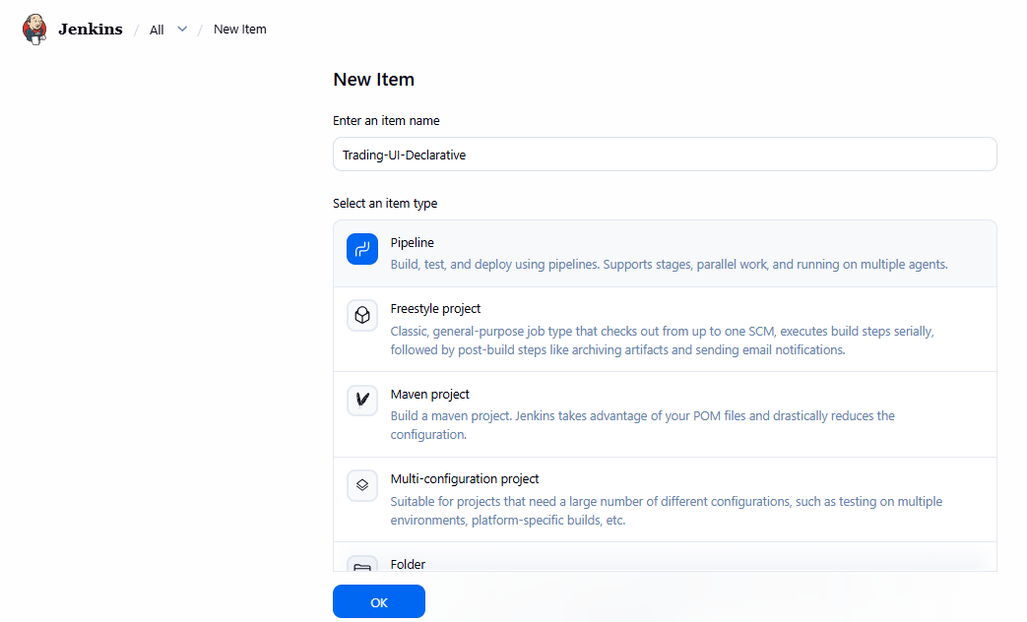
Step 2: Write the Declarative Pipeline script
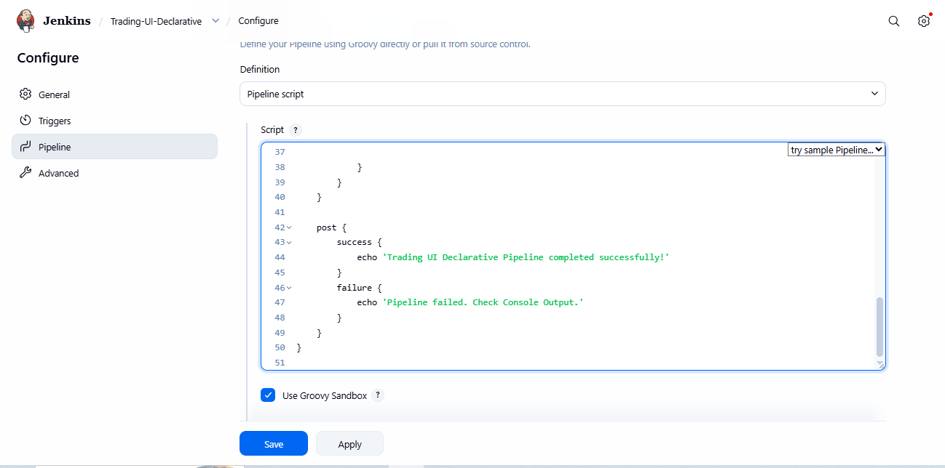

Step 3: Save and execute
- Click Save.
- Click Build Now.
- Click the latest build number.
- Click Console Output.
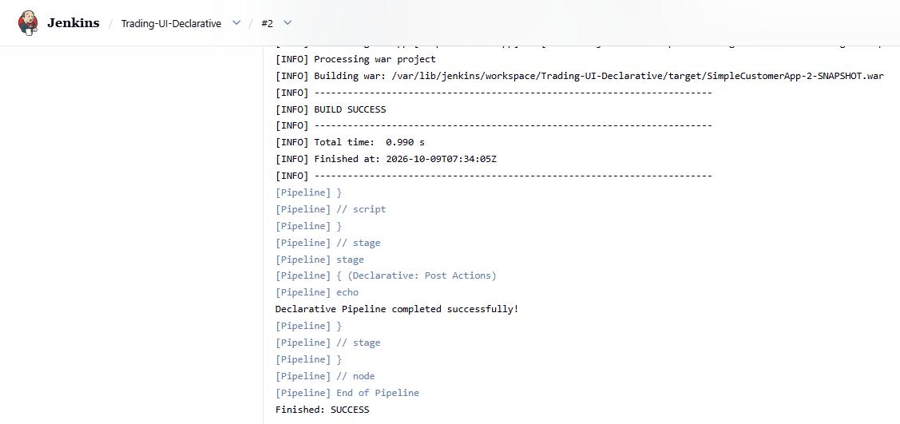
Stage view:
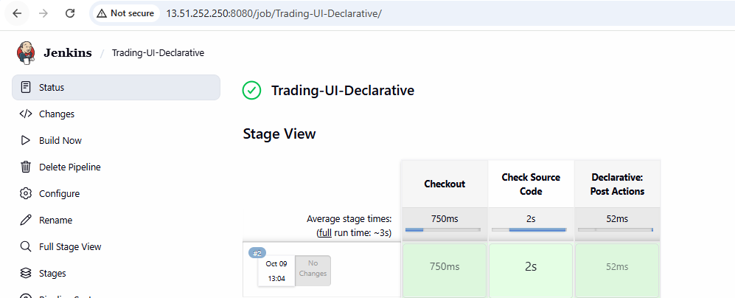
7. Execute parallel stages using Jenkins pipeline for any sample job

Step 1: Create a Jenkins Pipeline job
- Open your Jenkins dashboard.
- Click New Item.
- Enter the job name parallel-stages-demo.
- Select Pipeline and click OK.
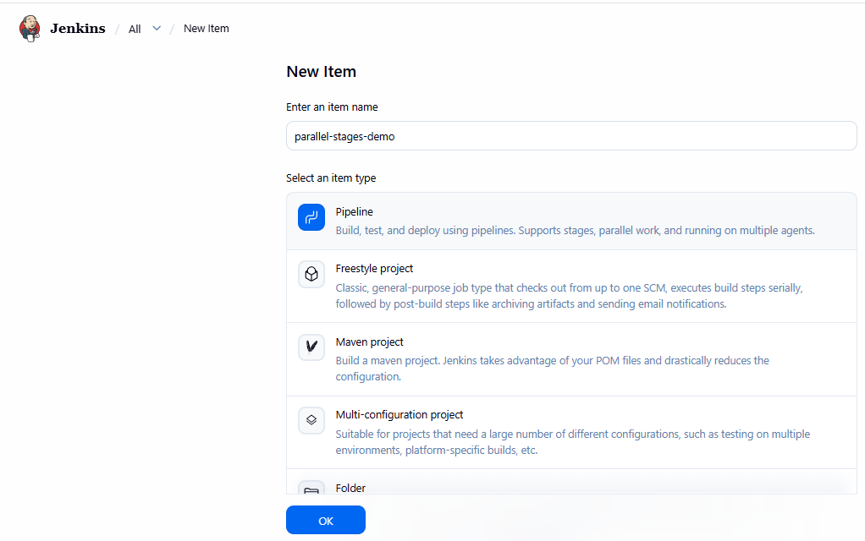
- Scroll down to the Pipeline section.
- Set Definition to Pipeline script.
Step 2: Write the pipeline script
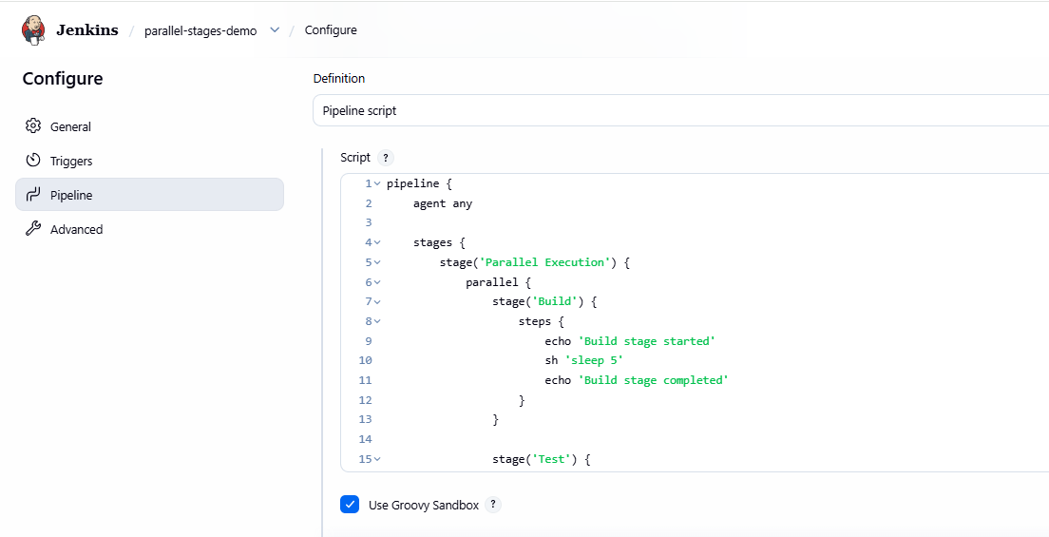
Save and click on build now.
Click the lastest build number
Check the console output.
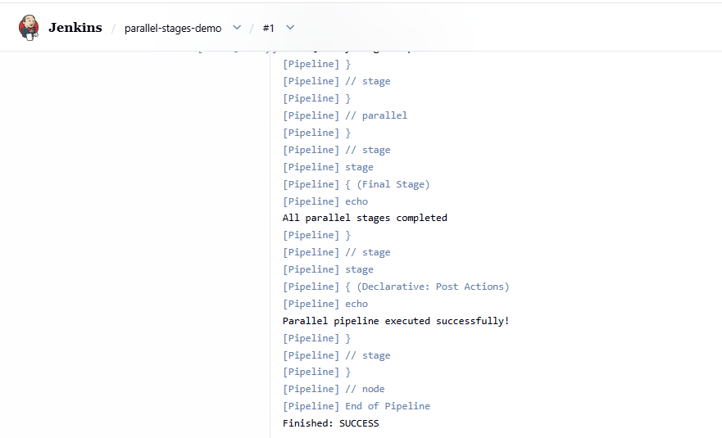
Stage view:
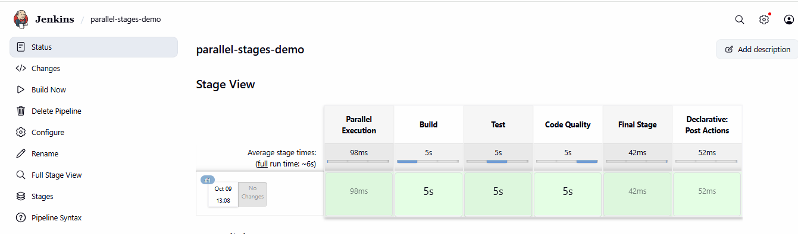
8. Execute Jenkins pipeline stages using shared libraries
- Reference: https://phoenixnap.com/kb/jenkins-shared-library

Step 1: Create a GitHub repository for the shared library
Create a new GitHub repository named jenkins-shared-library. You can make it public for this practice assignment.
The repository should have this structure:
jenkins-shared-library/
vars/

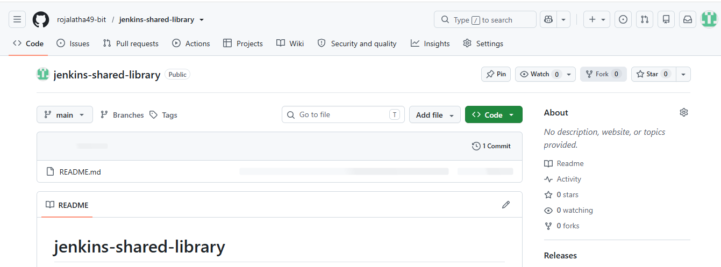

Step 2: Create the shared library files
In your new GitHub repository, create these two files inside the vars folder.
File 1: vars/buildApp.groovy
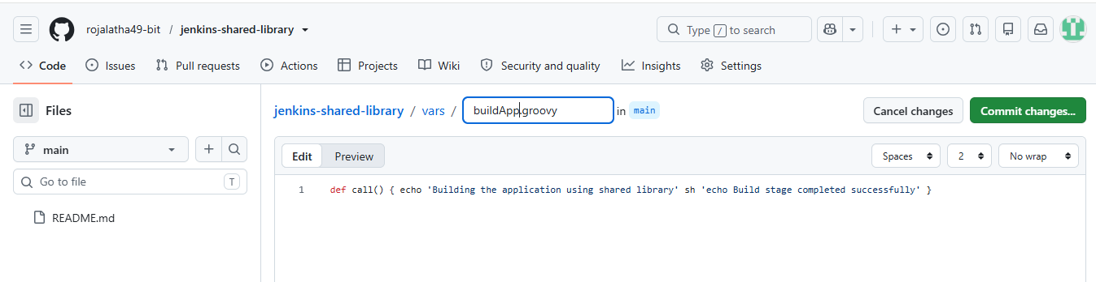
File 2: vars/testApp.groovy
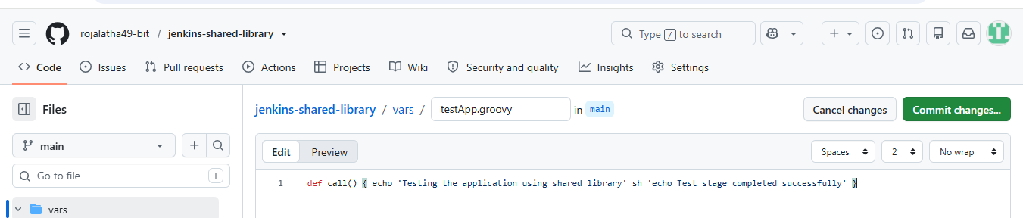
Commit both files to your GitHub repository.
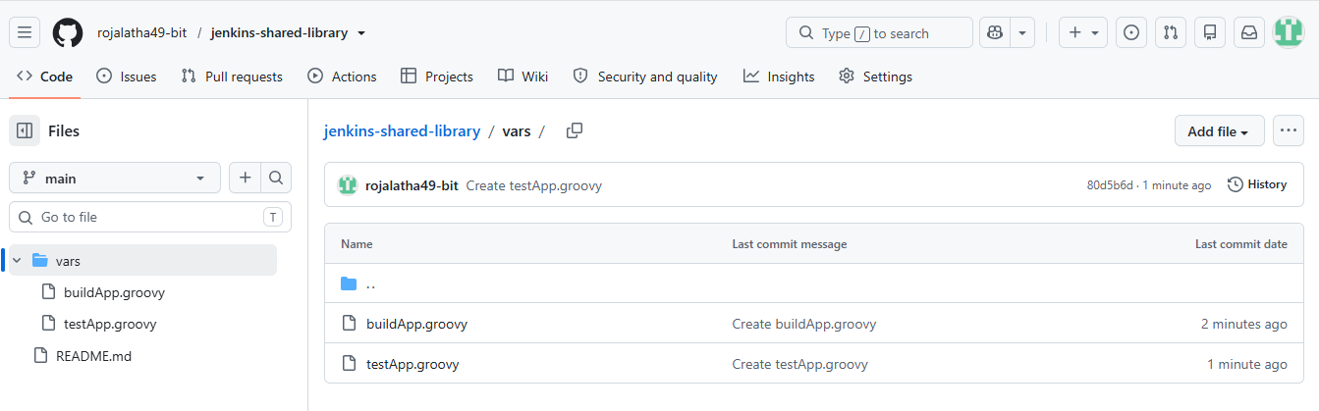

Step 3: Configure the shared library in Jenkins
- Open the Jenkins dashboard.
- Go to Manage Jenkins → System.
- Find the Global Trusted Pipeline Libraries or Global Pipeline Libraries section.
- Click Add.
- Enter the following settings.
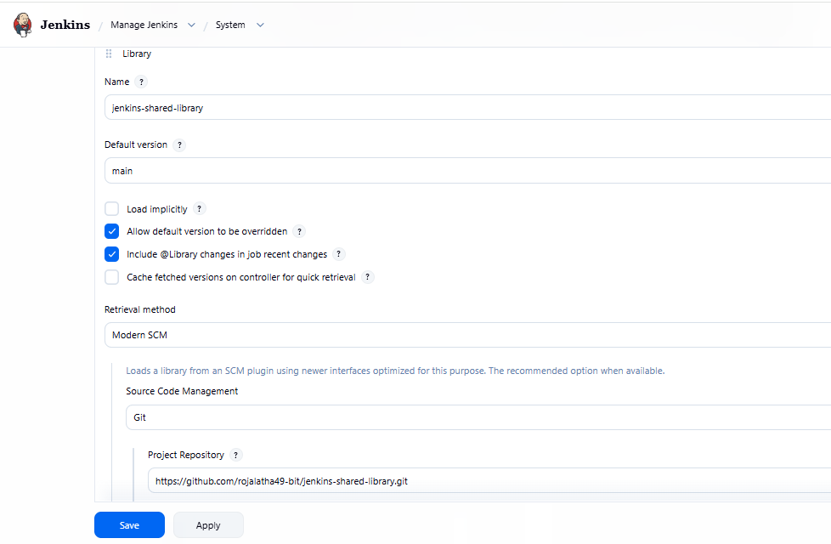
Click Save.

Step 4: Create a Jenkins Pipeline job
- Click New Item.
- Enter shared-library-pipeline.
- Select Pipeline, then click OK.
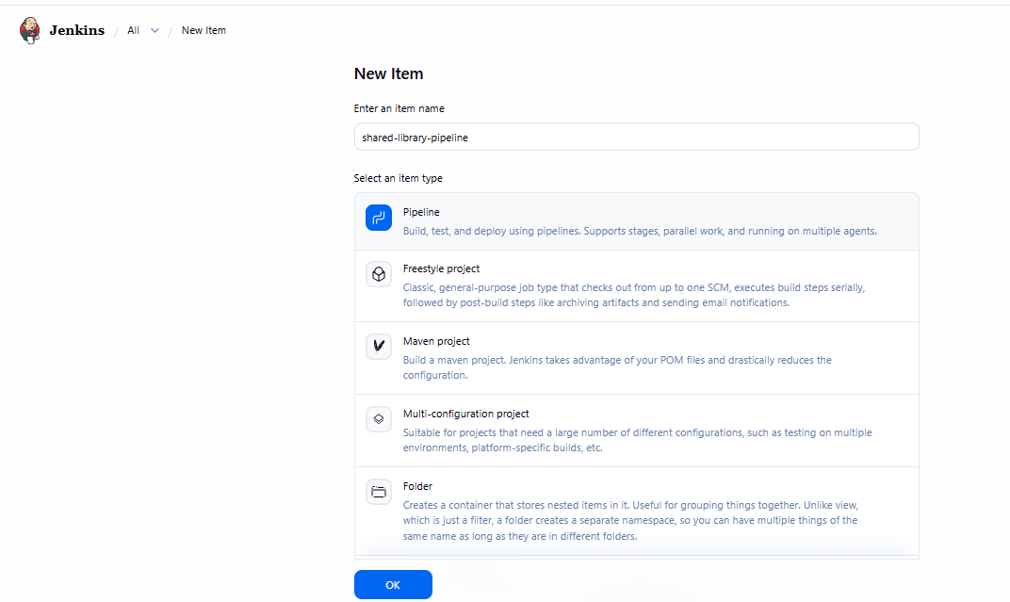
4. Under Pipeline, select Pipeline script.
5. Paste the following Jenkinsfile.
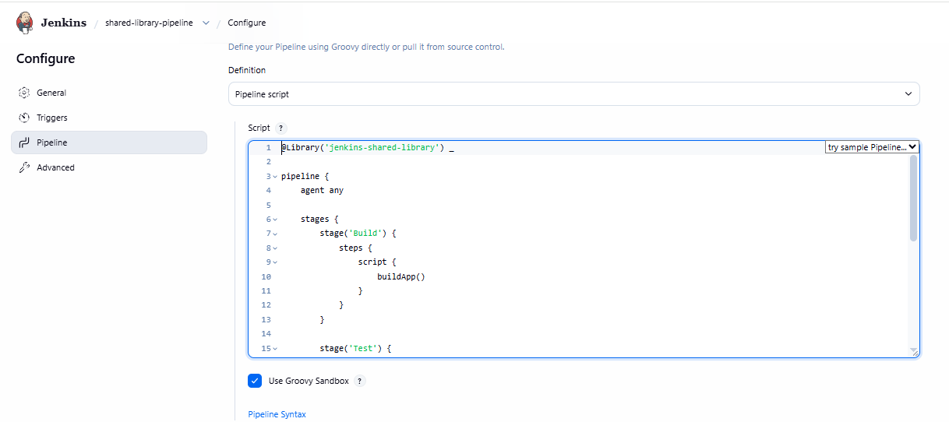
Click save.

Step 5: Execute the pipeline
- Open shared-library-pipeline.
- Click Build Now.
- Open the latest build number.
- Click Console Output.
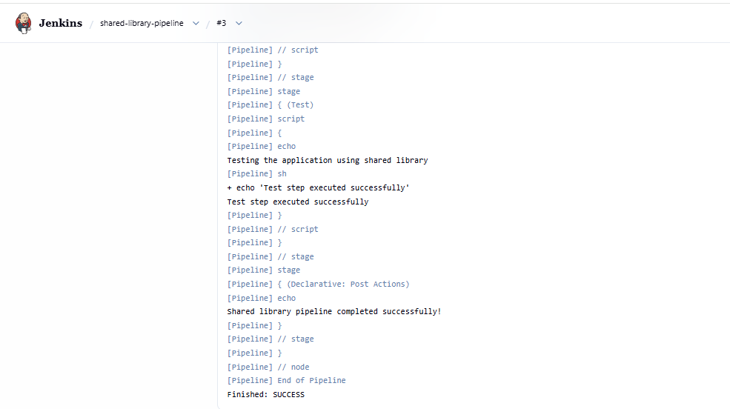
Stage view:
